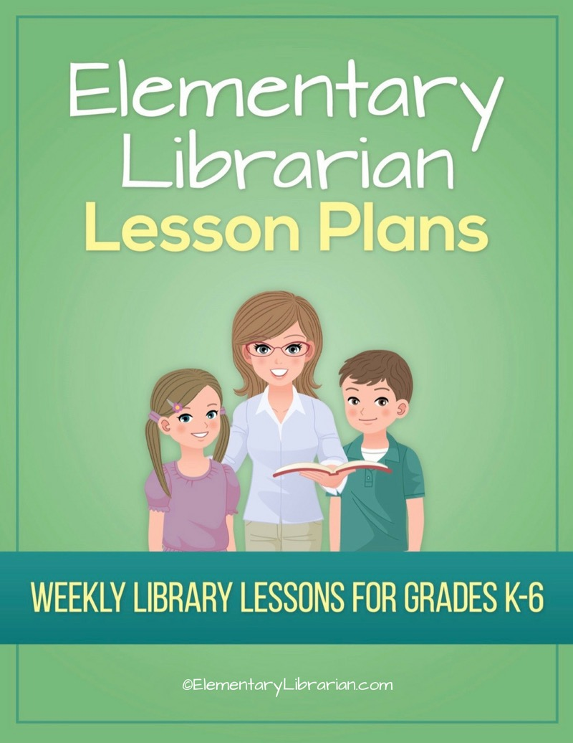

Kindergarten Month 1

Watch this video first!

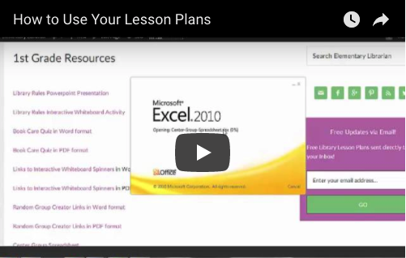
Video link: https://elementarylibrarian.com/how-to
These lesson plans were set up based on seeing classes for 35 minutes each. For more information, check out this article: http://elementarylibrarian.com/about-my-schedule
Here’s a link to the library curriculum map: http://elementarylibrarian.com/library-curriculum
Most of the lesson plans were intended to be used as library stations, or library centers. However, they can also be taught as standalone lessons if you prefer.
To learn more about different options for using these lessons, watch the video above or check out this article: http://elementarylibrarian.com/how-i-use-library-stations
All lesson plan purchases are subject to the Elementary Librarian Terms and Conditions.

Grade Level | K | Month | 1 | Week | 1

Objective | Students will get acquainted with the librarian and look around the library.
“I Can” Statement | I can name the school librarian (and library aide, if applicable.)

Common Core Standards | CC.K.L.4 Vocabulary Acquisition and Use: Determine or clarify the meaning of unknown and multiple-meaning words and phrases based on kindergarten reading and content.

AASL Standards | AASL.I.A.2 Inquire: Think: Competency 2: Learners display curiosity and initiative by recalling prior and background knowledge as context for new meaning.

Procedures | 1. Seat students on the story rug.  2. Introduce yourself and library staff, if applicable.  3. Ask students if they have visited the public library.  4. Explain the purpose of the school library and what they will do in the library each week.  5. Explain procedures for entering and exiting the library.  6. Demonstrate.  7. Practice entering and exiting the room with students.

Assessment | Ask students to name library staff. Students will demonstrate mastery of entering and exiting the room using the proper procedures.

Additional Resources

Grade Level | K | Month | 1 | Week | 2

Objective | Students will follow the librarian's directions.
“I Can” Statement | I can follow directions given by my teacher.

Common Core Standards | CC.K.R.I.10 Range of Reading and Level of Text Complexity: Actively engage in group reading activities with purpose and understanding.

AASL Standards | AASL.V.A.1 Explore: Think: Competency 1: Learners develop and satisfy personal curiosity by reading widely and deeply in multiple formats and write and create for a variety of purposes.  AASL.III.A.2 Collaborate: Think: Competency 2: Learners identify collaborative opportunities by developing new understanding through engagement in a learning group.

Procedures | 1. Seat students in front of interactive whiteboard.  2. Reintroduce yourself and staff, if applicable.  3. Explain what rules are and why we need them in the library.  4. Show library rules PowerPoint presentation.  5. Practice library exiting procedures.

Assessment | Students will describe the purpose of rules and follow directions for lining up.

Additional Resources

Grade Level | K | Month | 1 | Week | 3

Objective | Students will be able to choose a desirable behavior from two alternatives and demonstrate proper library behavior.
“I Can” Statement | I can choose the right library behavior. I can follow the rules.

Common Core Standards | CC.K.R.I.2 Key Ideas and Details: With prompting and support, identify the main topic and retell key details of a text.

AASL Standards | AASL.V.A.1 Explore: Think: Competency 1: Learners develop and satisfy personal curiosity by reading widely and deeply in multiple formats and write and create for a variety of purposes.

Procedures | 1. Assign seats to students.  2. Review library rules using interactive whiteboard activity.  3. Play Library Rules Charades: pair students up. One student will demonstrate the incorrect behavior and the other student will demonstrate the correct behavior.  4. Use the interactive whiteboard Name Spinner to randomly select students to tell the class which behavior is the correct one.

Assessment | Students will demonstrate their understanding of library rules by choosing the appropriate behaviors.

Additional Resources | Library rules review interactive whiteboard activity. interactive whiteboard random spinner.

Grade Level | K | Month | 1 | Week | 4

Objective | Students will be able to distinguish between appropriate and inappropriate library behavior.
“I Can” Statement | I can choose the right library behavior. I can follow the rules.

Common Core Standards | CC.K.R.I.2 Key Ideas and Details: With prompting and support, identify the main topic and retell key details of a text.

AASL Standards | AASL.V.A.1 Explore: Think: Competency 1: Learners develop and satisfy personal curiosity by reading widely and deeply in multiple formats and write and create for a variety of purposes.

Procedures | 1. Prepare game materials before students arrive.  2.Seat students at story rug.  3. Randomly select 4 students to play the Library Rules board game.  4. Rotate students so everyone gets a turn.  5. Alternatively, you could distribute the Library Rules written activity and guide students through it.

Assessment | Students will distinguish between desirable and undesirable behaviors in the library.

Additional Resources | Library rules board game  Library Rules activity

