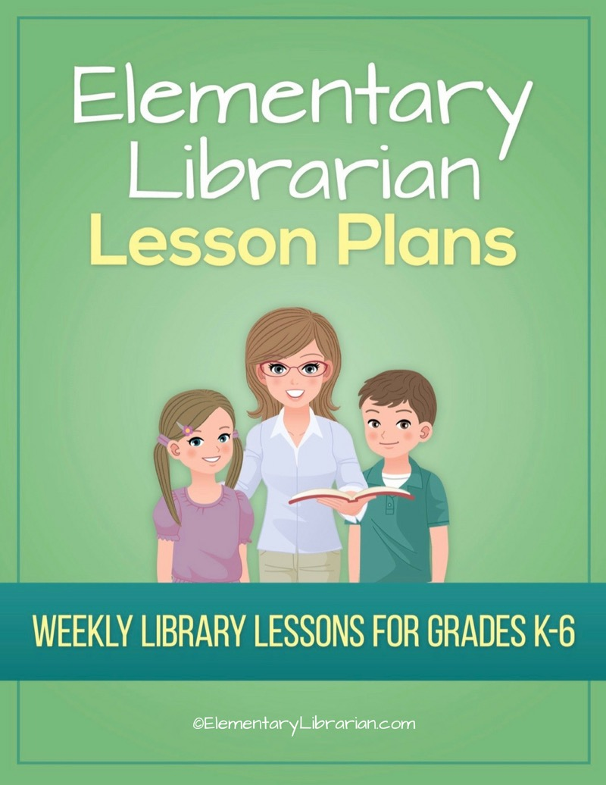

1st Grade Month 1
Watch this video first!
Video link: https://elementarylibrarian.com/how-to
These lesson plans were set up based on seeing classes for 35 minutes each. For more information, check out this article: http://elementarylibrarian.com/about-my-schedule
Here’s a link to the library curriculum map: http://elementarylibrarian.com/library-curriculum
Most of the lesson plans were intended to be used as library stations, or library centers. However, they can also be taught as standalone lessons if you prefer.
To learn more about different options for using these lessons, watch the video above or check out this article: http://elementarylibrarian.com/how-i-use-library-stations
All lesson plan purchases are subject to the Elementary Librarian Terms and Conditions.

Grade Level | 1 | Month | 1 | Week | 1

Objective | Students will recall using the school library in the past and discuss things they would like to do during the current school year.
“I Can” Statement | I can describe activities I'd like to do in library class during the school year.

Common Core Standards | CC.1.SL.1 Comprehension and Collaboration: Participate in collaborative conversations with diverse partners about grade 1 topics and texts with peers and adults in small and larger groups.

AASL Standards | AASL.III.D.1 Collaborate: Grow: Competency 1: Learners actively participate with others in learning situations by actively contributing to group discussions.  AASL.III.D.2 Collaborate: Grow: Competency 2: Learners actively participate with others in learning situations by recognizing learning as a social responsibility.
 | AASL.II.C.2 Include: Share: Competency 2: Learners exhibit empathy with and tolerance for diverse ideas by contributing to discussions in which multiple viewpoints on a topic are expressed.

Procedures | 1. Seat students on the story rug.  2. Introduce library staff to new students.  3. Discuss things students liked about library class last year.  4. Review procedures for entering and exiting the library.  5. Demonstrate.  6. Practice entering and exiting the room with students.

Assessment | Students will demonstrate mastery of entering and exiting the room using the proper procedures.

Additional Resources

Grade Level | 1 | Month | 1 | Week | 2

Objective | Students will follow the librarian's directions.
“I Can” Statement | I can follow directions given by my teacher.

Common Core Standards | CC.1.SL.2 Comprehension and Collaboration: Ask and answer questions about key details in a text read aloud or information presented orally or through other media.

AASL Standards | AASL.V.A.1 Explore: Think: Competency 1: Learners develop and satisfy personal curiosity by reading widely and deeply in multiple formats and write and create for a variety of purposes.
AASL.IV.A.3 Curate: Think: Competency 3: Learners act on an information need by making critical choices about information sources to use.

AASL.IV.B.4 Curate: Create: Competency 4: Learners gather information appropriate to the task by organizing information by priority, topic, or other systematic scheme

Procedures | 1. Seat students in front of interactive whiteboard.  2. Talk about library rules and emergency procedures.  3. Show library rules PowerPoint presentation.  4. Students will choose the proper library behavior on the library rules interactive whiteboard activity.  5. Practice library exiting procedures.

Assessment | Students will demonstrate that they are able to follow library rules by choosing the correct library behavior on the library rules presentation.

Additional Resources | Library rules PowerPoint presentation  Library Rules interactive whiteboard Activity

Grade Level | 1 | Month | 1 | Week | 3

Objective | Students will be able to recognize the proper way to treat library books.
“I Can” Statement | I can choose proper book care behaviors.

Common Core Standards | CC.1.SL.2 Comprehension and Collaboration: Ask and answer questions about key details in a text read aloud or information presented orally or through other media.

AASL Standards | AASL.V.A.1 Explore: Think: Competency 1: Learners develop and satisfy personal curiosity by reading widely and deeply in multiple formats and write and create for a variety of purposes.

Procedures | 1. Assign seats to students.  2. Review proper book care practices using the Book Care Quiz.  3. If time allows, play Library Rules Charades: pair students up. One student will demonstrate the incorrect behavior and the other student will demonstrate the correct behavior.  4. Use the interactive whiteboard Name Spinner to randomly select students to tell the class which behavior is the correct one.

Assessment | Students will demonstrate their understanding of book care techniques by choosing the appropriate behaviors.

Additional Resources | Book Care Quiz  Interactive whiteboard random spinner links

Grade Level | 1 | Month | 1 | Week | 4

Objective | Students will be able to follow library rules and follow procedures for checking out books.
“I Can” Statement | I can follow library rules. I can follow directions for checking out books.

Common Core Standards | CC.1.SL.2 Comprehension and Collaboration: Ask and answer questions about key details in a text read aloud or information presented orally or through other media.

AASL Standards | AASL.V.A.1 Explore: Think: Competency 1: Learners develop and satisfy personal curiosity by reading widely and deeply in multiple formats and write and create for a variety of purposes.

Procedures | 1. Review seat assignments.  2. Ask students to name a library rule.  3. Review library checkout procedures: how to return books, how to find a new book, how to use shelf markers, how to scan books, and what to do when you have selected your book/s.  4. Practice proper checkout procedures if time allows.

Assessment | Students will name library rules. Students will demonstrate proper checkout procedures.

Additional Resources

