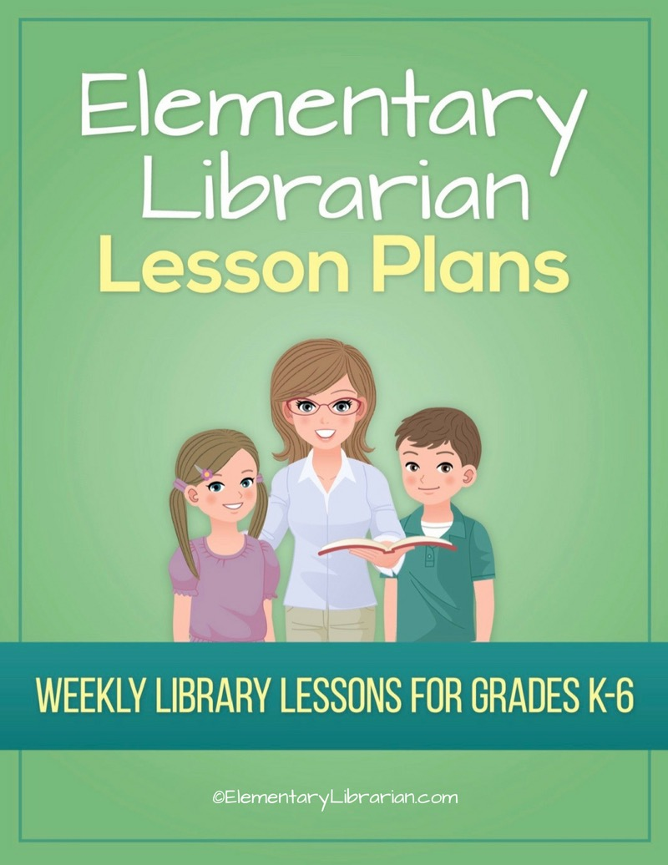

2nd Grade Month 1

Watch this video first!
Video link: https://elementarylibrarian.com/how-to
These lesson plans were set up based on seeing classes for 35 minutes each. For more information, check out this article: http://elementarylibrarian.com/about-my-schedule
Here’s a link to the library curriculum map: http://elementarylibrarian.com/library-curriculum
Most of the lesson plans were intended to be used as library stations, or library centers. However, they can also be taught as standalone lessons if you prefer.
To learn more about different options for using these lessons, watch the video above or check out this article: http://elementarylibrarian.com/how-i-use-library-stations
All lesson plan purchases are subject to the Elementary Librarian Terms and Conditions.

Grade Level | 2 | Month | 1 | Week | 1

Objective | Students will recall using the school library in the past and discuss things they would like to do during the current school year.
“I Can” Statement | I can describe activities I'd like to do in library class during the school year.

Common Core Standards | CC.2.SL.1 Comprehension and Collaboration: Participate in collaborative conversations with diverse partners about grade 2 topics and texts with peers and adults in small and larger groups.

AASL Standards | AASL.III.A.2 Collaborate: Think: Competency 2: Learners identify collaborative opportunities by developing new understanding through engagement in a learning group.  AASL.III.C.2 Collaborate: Share: Competency 2: Learners work productively with others to solve problems by involving diverse perspectives in their own inquiry process.

Procedures | 1. Seat students on the story rug.  2. Introduce library staff to new students.  3. Discuss things students liked about library class last year.  4. Briefly discuss some of the things we'll do during the upcoming school year.  5. Review procedures for entering and exiting the library.  6. Demonstrate.  7. Practice entering and exiting the room with students.

Assessment | Students will demonstrate mastery of entering and exiting the room using the proper procedures.

Additional Resources

Grade Level | 2 | Month | 1 | Week | 2

Objective | Students will follow the librarian's directions.
“I Can” Statement | I can follow directions given by my teacher.

Common Core Standards | CC.2.SL.5 Presentation of Knowledge and Ideas: Create audio recordings of stories or poems; add drawings or other visual displays to stories or recounts of experiences when appropriate to clarify ideas, thoughts, and feelings.
 | CC.2.SL.2 Comprehension and Collaboration: Recount or describe key ideas or details from a text read aloud or information presented orally or through other media.

AASL Standards | AASL.I.B.3 Inquire: Create: Competency 3: Learners engage with new knowledge by following a process that includes generating products that illustrate learning.  AASL.V.A.1 Explore: Think: Competency 1: Learners develop and satisfy personal curiosity by reading widely and deeply in multiple formats and write and create for a variety of purposes.

Procedures | 1. Seat students in front of Smart Board.  2. Talk about library rules.  3. Show library rules PowerPoint presentation.  4. Ask students to create a poster displaying one of the library's rules.  4. Practice putting materials away correctly and practice exiting library.

Assessment | Students will demonstrate an understanding of library rules by creating a poster about what they've learned.

Additional Resources | Library Rules PowerPoint presentation

Grade Level | 2 | Month | 1 | Week | 3

Objective | Students will be able to recognize the proper way to treat library books.
“I Can” Statement | I can choose proper book care behaviors.

Common Core Standards | CC.2.SL.2 Comprehension and Collaboration: Recount or describe key ideas or details from a text read aloud or information presented orally or through other media.

AASL Standards | AASL.V.A.1 Explore: Think: Competency 1: Learners develop and satisfy personal curiosity by reading widely and deeply in multiple formats and write and create for a variety of purposes.

Procedures | 1. Assign seats to students.  2. Review library rules.  3. Review proper book care behaviors using the Book Care Quiz.

Assessment | Students will demonstrate their understanding of book care techniques by choosing the appropriate behaviors.

Additional Resources | Book Care Quiz

Grade Level | 2 | Month | 1 | Week | 4

Objective | Students will be able to follow library rules and follow procedures for checking out books.
“I Can” Statement | I can follow library rules. I can follow directions for checking out books.

Common Core Standards | CC.2.R.I.1 Key Ideas and Details: Ask and answer such questions as who, what, where, when, why, and how to demonstrate understanding of key details in a text.

AASL Standards | AASL.V.A.1 Explore: Think: Competency 1: Learners develop and satisfy personal curiosity by reading widely and deeply in multiple formats and write and create for a variety of purposes.

Procedures | 1. Review seat assignments.  2. Ask students to name a library rule.  3. Review library checkout procedures: how to return books, how to find a new book, how to use shelf markers, how to scan books, and what to do when you have selected your book/s.  4. Practice proper checkout procedures if time allows.

Assessment | Students will name library rules. Students will demonstrate proper checkout procedures.

Additional Resources

