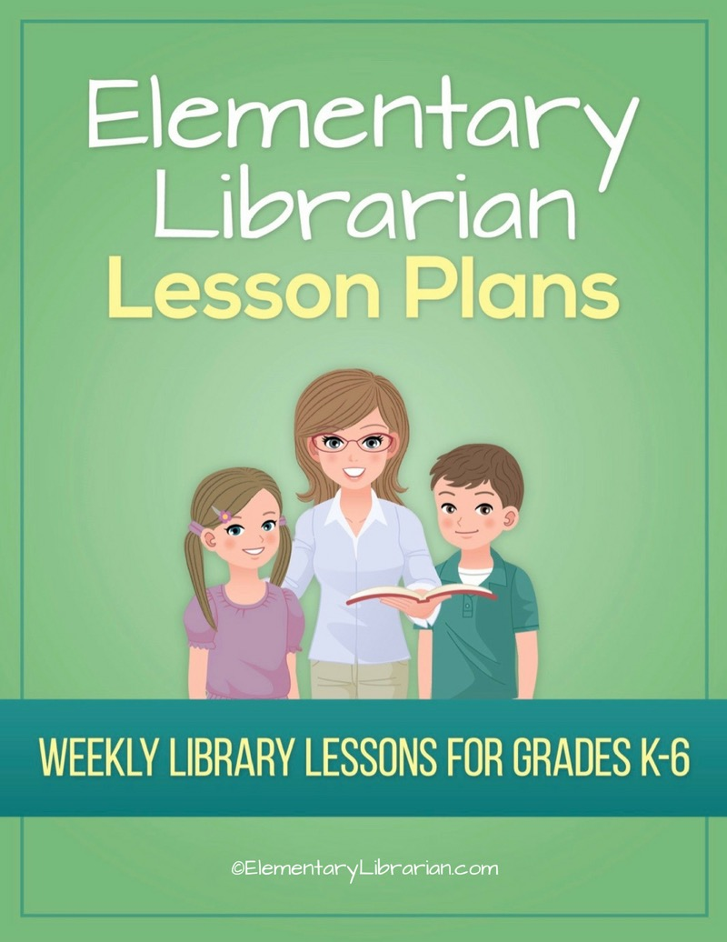

3rd Grade Month 1
Watch this video first!
Video link: https://elementarylibrarian.com/how-to
These lesson plans were set up based on seeing classes for 35 minutes each. For more information, check out this article: http://elementarylibrarian.com/about-my-schedule
Here’s a link to the library curriculum map: http://elementarylibrarian.com/library-curriculum
Most of the lesson plans were intended to be used as library stations, or library centers. However, they can also be taught as standalone lessons if you prefer.
To learn more about different options for using these lessons, watch the video above or check out this article: http://elementarylibrarian.com/how-i-use-library-stations
All lesson plan purchases are subject to the Elementary Librarian Terms and Conditions.

Grade Level | 3 | Month | 1 | Week | 1

Objective | Students will recall using the school library in the past and discuss things they would like to do during the current school year. Students will have an assigned seat and go to that seat when directed.
“I Can” Statement | I can describe activities I'd like to do in library class during the school year. I can go to my assigned seat when directed by my teacher.

Common Core Standards | CC.3.SL.1.d Comprehension and Collaboration: Explain their own ideas and understanding in light of the discussion.

AASL Standards | AASL.I.A.2 Inquire: Think: Competency 2: Learners display curiosity and initiative by recalling prior and background knowledge as context for new meaning.  AASL.III.B.2 Collaborate: Create: Competency 2: Learners participate in personal, social, and intellectual networks by establishing connections with other learners to build on their own prior knowledge and create new knowledge.
AASL.III.A.2 Collaborate: Think: Competency 2: Learners identify collaborative opportunities by developing new understanding through engagement in a learning group.

AASL.III.C.2 Collaborate: Share: Competency 2: Learners work productively with others to solve problems by involving diverse perspectives in their own inquiry process.

Procedures | 1. Seat students at tables according to seating chart.  2. Introduce library staff to new students.  3. Discuss things students liked about library class last year.  4. Review procedures for entering and exiting the library.  5. Practice entering and exiting the room with students.

Assessment | Students will demonstrate mastery of entering and exiting the room using the proper procedures. Students will go to their assigned seat when entering the room.

Additional Resources

Grade Level | 3 | Month | 1 | Week | 2

Objective | Students will create bookmarks that describe library rules.
“I Can” Statement | I can create a bookmark about library rules.

Common Core Standards | CC.3.SL.4 Presentation of Knowledge and Ideas: Report on a topic or text, tell a story, or recount an experience with appropriate facts and relevant, descriptive details, speaking clearly at an understandable pace.
 | CC.3.SL.2 Comprehension and Collaboration: Determine the main ideas and supporting details of a text read aloud or information presented in diverse media and formats, including visually, quantitatively, and orally.

AASL Standards | AASL.V.A.1 Explore: Think: Competency 1: Learners develop and satisfy personal curiosity by reading widely and deeply in multiple formats and write and create for a variety of purposes.
 | AASL.I.B.3 Inquire: Create: Competency 3: Learners engage with new knowledge by following a process that includes generating products that illustrate learning.

Procedures | 1. Seat students in assigned seats at tables.  2. Talk about library rules.  3. Show library rules PowerPoint presentation.  4. Ask students to create bookmarks displaying one of the library's rules.  4. Practice putting materials away correctly  5. Practice exiting library.

Assessment | Students will demonstrate an understanding of library rules by creating bookmarks about what they've learned.

Additional Resources | Library rules Prezi  Library rules bookmarks template

Grade Level | 3 | Month | 1 | Week | 3

Objective | Students will be able to recall book care rules and create a poster for younger students.
“I Can” Statement | I can create a poster about book care.

Common Core Standards | CC.3.SL.4 Presentation of Knowledge and Ideas: Report on a topic or text, tell a story, or recount an experience with appropriate facts and relevant, descriptive details, speaking clearly at an understandable pace.
 | CC.3.SL.2 Comprehension and Collaboration: Determine the main ideas and supporting details of a text read aloud or information presented in diverse media and formats, including visually, quantitatively, and orally.

AASL Standards | AASL.V.A.1 Explore: Think: Competency 1: Learners develop and satisfy personal curiosity by reading widely and deeply in multiple formats and write and create for a variety of purposes.
 | AASL.I.B.3 Inquire: Create: Competency 3: Learners engage with new knowledge by following a process that includes generating products that illustrate learning.

Procedures | 1. Seat students in assigned seats at tables.  2. Talk about book care rules.  3. Read Penelope Popper, Book Doctor aloud.  4. Ask students to create bookmarks displaying one of the library's rules.  4. Ask comprehension questions.  5. Students will use blank paper/poster board to create a book care poster for younger students.

Assessment | Students will recall a book care rule and create a poster depicting that rule.

Additional Resources | Art supplies  Penelope Popper, Book Doctor by Toni Buzzeo

Grade Level | 3 | Month | 1 | Week | 4

Objective | Students will be able to search the OPAC and use proper checkout procedures.
“I Can” Statement | I can search the OPAC. I can demonstrate proper checkout procedures.

Common Core Standards | CC.3.W.8 Research to Build and Present Knowledge: Recall information from experiences or gather information from print and digital sources; take brief notes on sources and sort evidence into provided categories.

AASL Standards | AASL.IV.B.1 Curate: Create: Competency 1: Learners gather information appropriate to the task by seeking a variety of sources.  AASL.IV.B.4 Curate: Create: Competency 4: Learners gather information appropriate to the task by organizing information by priority, topic, or other systematic scheme.

Procedures | 1. Direct students to their assigned seats.  2. Do a short demonstration on how to search OPAC.  3. Introduce reading incentive programs and review rules.  4. If time allows, students should practice OPAC searches at the computer stations.

Assessment | Students will demonstrate their understanding of checkout procedures by choosing the appropriate behaviors and describing why other behaviors are undesired.

Additional Resources

