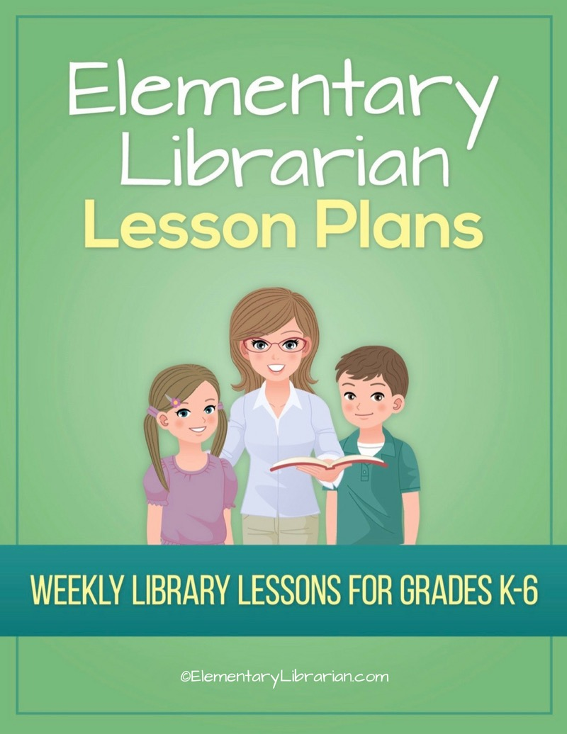

5th Grade Month 1

Watch this video first!
Video link: https://elementarylibrarian.com/how-to
These lesson plans were set up based on seeing classes for 35 minutes each. For more information, check out this article: http://elementarylibrarian.com/about-my-schedule
Here’s a link to the library curriculum map: http://elementarylibrarian.com/library-curriculum
Most of the lesson plans were intended to be used as library stations, or library centers. However, they can also be taught as standalone lessons if you prefer.
To learn more about different options for using these lessons, watch the video above or check out this article: http://elementarylibrarian.com/how-i-use-library-stations
All lesson plan purchases are subject to the Elementary Librarian Terms and Conditions.

Grade Level | 5 | Month | 1 | Week | 1

Objective | Students will recall using the school library in the past. Students will have an assigned seat and go to that seat when directed.
“I Can” Statement | I can go to my assigned seat when directed by my teacher.

Common Core Standards | CC.5.SL.1.b Comprehension and Collaboration: Follow agreed-upon rules for discussions and carry out assigned roles.
 | CC.5.SL.1.c Comprehension and Collaboration: Pose and respond to specific questions by making comments that contribute to the discussion and elaborate on the remarks of others.

AASL Standards | AASL.I.C.4 Inquire: Share: Competency 4: Learners adapt, communicate, and exchange learning products with others in a cycle that includes sharing products with an authentic audience.  AASL.VI.C.2 Engage: Share: Competency 2: Learners responsibly, ethically, and legally share new information with a global community by disseminating new knowledge through means appropriate for the intended audience.
 | AASL.III.D.2 Collaborate: Grow: Competency 2: Learners actively participate with others in learning situations by recognizing learning as a social responsibility.

Procedures | 1. Seat students at tables according to seating chart.  2. Introduce library staff to new students. 3. Discuss things students liked about library class last year.  4. Review procedures for entering and exiting the library.  5. Practice entering and exiting the room with students.

Assessment | Students will demonstrate mastery of entering and exiting the room using the proper procedures. Students will go to their assigned seat when entering the room.

Additional Resources

Grade Level | 5 | Month | 1 | Week | 2

Objective | Students will be able to identify desirable library behaviors.
“I Can” Statement | I can correctly identify library rules.

Common Core Standards | CC.5.R.I.7 Integration of Knowledge and Ideas: Draw on information from multiple print or digital sources, demonstrating the ability to locate an answer to a question quickly or to solve a problem efficiently.

AASL Standards | AASL.V.A.1 Explore: Think: Competency 1: Learners develop and satisfy personal curiosity by reading widely and deeply in multiple formats and write and create for a variety of purposes.

Procedures | 1. Seat students in their assigned seats at tables.  2. Talk about library rules.  3. Show library rules Prezi.  4. Play Library Rules Jeopardy in teams or as a class.  5. Practice exiting library.

Assessment | Students will demonstrate their understanding of library rules by correctly answering the game questions.

Additional Resources | Library rules Prezi  Library Rules Jeopardy game

Grade Level | 5 | Month | 1 | Week | 3

Objective | Students will create a quiz about book care for their peers.
“I Can” Statement | I can create a quiz about book care.

Common Core Standards | CC.5.W.8 Research to Build and Present Knowledge: Recall relevant information from experiences or gather relevant information from print and digital sources; summarize or paraphrase information in notes and finished work, and provide a list of sources.

AASL Standards | AASL.I.B.3 Inquire: Create: Competency 3: Learners engage with new knowledge by following a process that includes generating products that illustrate learning.  AASL.VI.C.2 Engage: Share: Competency 2: Learners responsibly, ethically, and legally share new information with a global community by disseminating new knowledge through means appropriate for the intended audience.  AASL.V.A.1 Explore: Think: Competency 1: Learners develop and satisfy personal curiosity by reading widely and deeply in multiple formats and write and create for a variety of purposes.

Procedures | 1. Seat students at tables.  2. Briefly discuss proper book care behaviors.  3. Distribute blank paper and pencils.  4. Students will create a book care quiz for another classmate.  5. Once the quiz is complete, they should try to answer another classmate's quiz questions.  6. If time allows, students may type their completed quiz.

Assessment | Students will ask relevant questions about book care and answer book care questions correctly.

Additional Resources

Grade Level | 5 | Month | 1 | Week | 4

Objective | Students will be able to search the OPAC and use proper checkout procedures.
“I Can” Statement | I can search the OPAC. I can demonstrate proper checkout procedures.

Common Core Standards | CC.5.W.8 Research to Build and Present Knowledge: Recall relevant information from experiences or gather relevant information from print and digital sources; summarize or paraphrase information in notes and finished work, and provide a list of sources.

AASL Standards | AASL.I.D.2 Inquire: Grow: Competency 2: Learners participate in an ongoing inquiry-based process by engaging in sustained inquiry.  AASL.IV.B.1 Curate: Create: Competency 1: Learners gather information appropriate to the task by seeking a variety of sources.  AASL.VI.A.3 Engage: Think: Competency 3: Learners follow ethical and legal guidelines for gathering and using information by evaluating information for accuracy, validity, social, and cultural context, and appropriateness for need.
 | AASL.IV.B.4 Curate: Create: Competency 4: Learners gather information appropriate to the task by organizing information by priority, topic, or other systematic scheme.

Procedures | 1. Seat students at tables.  2. Talk about organization in the library.  3. Demonstrate using the OPAC as review (or an introduction for new students).  4. Review checkout procedures.  5. If time allows, students should practice finding books using OPAC.

Assessment | Students will use the OPAC to find books they're searching for.

Additional Resources

