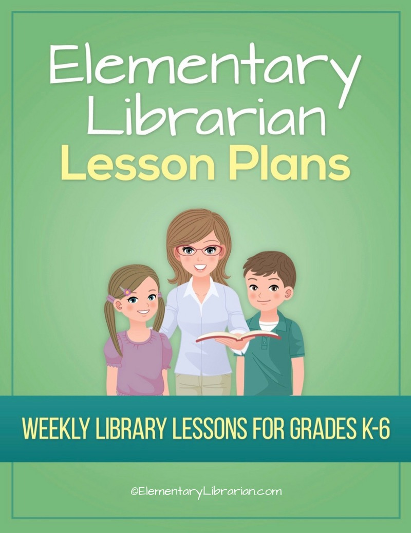

6th Grade Month 1

Watch this video first!
Video link: https://elementarylibrarian.com/how-to
These lesson plans were set up based on seeing classes for 35 minutes each. For more information, check out this article: http://elementarylibrarian.com/about-my-schedule
Here’s a link to the library curriculum map: http://elementarylibrarian.com/library-curriculum
Most of the lesson plans were intended to be used as library stations, or library centers. However, they can also be taught as standalone lessons if you prefer.
To learn more about different options for using these lessons, watch the video above or check out this article: http://elementarylibrarian.com/how-i-use-library-stations
All lesson plan purchases are subject to the Elementary Librarian Terms and Conditions.

Grade Level | 6 | Month | 1 | Week | 1

Objective | Students will recall using the school library in the past. Students will have an assigned seat and go to that seat when directed.
“I Can” Statement | I can go to my assigned seat when directed by my teacher.

Common Core Standards | CC.6.SL.1 Comprehension and Collaboration: Engage effectively in a range of collaborative discussions (one-on-one, in groups, and teacher-led) with diverse partners on grade 6 topics, texts, and issues, building on others' ideas and expressing their own clearly.
 | CC.6.SL.1.c Comprehension and Collaboration: Pose and respond to specific questions with elaboration and detail by making comments that contribute to the topic, text, or issue under discussion.

AASL Standards | AASL.I.C.4 Inquire: Share: Competency 4: Learners adapt, communicate, and exchange learning products with others in a cycle that includes sharing products with an authentic audience.
AASL.III.D.2 Collaborate: Grow: Competency 2: Learners actively participate with others in learning situations by recognizing learning as a social responsibility.

AASL.III.A.2 Collaborate: Think: Competency 2: Learners identify collaborative opportunities by developing new understanding through engagement in a learning group.

Procedures | 1. Seat students at tables according to seating chart.  2. Introduce library staff to new students.  3. Discuss things students liked about library class last year.  4. Review procedures for entering and exiting the library.  5. Practice entering and exiting the room with students.

Assessment | Students will demonstrate mastery of entering and exiting the room using the proper procedures. Students will go to their assigned seat when entering the room.

Additional Resources

Grade Level | 6 | Month | 1 | Week | 2

Objective | Students will be able to identify desirable library behaviors.
“I Can” Statement | I can correctly identify library rules.

Common Core Standards | CC.6.R.I.7 Integration of Knowledge and Ideas: Integrate information presented in different media or formats (e.g., visually, quantitatively) as well as in words to develop a coherent understanding of a topic or issue.

AASL Standards | AASL.V.A.1 Explore: Think: Competency 1: Learners develop and satisfy personal curiosity by reading widely and deeply in multiple formats and write and create for a variety of purposes.

Procedures | 1. Seat students in their assigned seats at tables.  2. Talk about library rules.  3. Show library rules PowerPoint presentation.  4. Play Library Rules Jeopardy in teams or as a class.  5. Practice exiting library.

Assessment | Students will demonstrate their understanding of library rules by correctly answering the game questions.

Additional Resources | Library rules PowerPoint presentation  Library Rules Jeopardy game

Grade Level | 6 | Month | 1 | Week | 3

Objective | Students will create a short presentation about book care for their peers.
“I Can” Statement | I can create a short presentation about book care.

Common Core Standards | CC.6.SL.5 Presentation of Knowledge and Ideas: Include multimedia components (e.g., graphics, images, music, sound) and visual displays in presentations to clarify information.

AASL Standards | AASL.I.B.3 Inquire: Create: Competency 3: Learners engage with new knowledge by following a process that includes generating products that illustrate learning.  AASL.VI.C.2 Engage: Share: Competency 2: Learners responsibly, ethically, and legally share new information with a global community by disseminating new knowledge through means appropriate for the intended audience.

Procedures | 1. Seat students at tables.  2. Briefly discuss proper book care behaviors.  3. Distribute art materials or students can go to computer stations if desired. Students may work individually or in partners/groups.  4. Students will create a book care presentation for the rest of the class. Depending on timing issues, you may want to assign 1 or 2 book rules to each student/group.  5. If time allows, students will present their finished product to the rest of the class.

Assessment | Students will create a presentation based on 1 or 2 book care rules.

Additional Resources

Grade Level | 6 | Month | 1 | Week | 4

Objective | Students will be able to search the OPAC and use proper checkout procedures.
“I Can” Statement | I can search the OPAC. I can demonstrate proper checkout procedures.

Common Core Standards | CC.6.W.9 Research to Build and Present Knowledge: Draw evidence from literary or informational texts to support analysis, reflection, and research.

AASL Standards | AASL.I.B.1 Inquire: Create: Competency 1 Learners engage with new knowledge by following a process that includes using evidence to investigate questions.  AASL.IV.B.3 Curate: Create: Competency 3: Learners gather information appropriate to the task by systematically questioning and assessing the validity and accuracy of information.  AASL.IV.B.4 Curate: Create: Competency 4: Learners gather information appropriate to the task by organizing information by priority, topic, or other systematic scheme.  AASL.IV.B.1 Curate: Create: Competency 1: Learners gather information appropriate to the task by seeking a variety of sources.  AASL.VI.A.3 Engage: Think: Competency 3: Learners follow ethical and legal guidelines for gathering and using information by evaluating information for accuracy, validity, social, and cultural context, and appropriateness for need.

Procedures | 1. Seat students at tables.  2. Talk about organization in the library.  3. Demonstrate using the OPAC as review (or an introduction for new students).  4. Review checkout procedures.  5. If time allows, students should practice finding books using OPAC.

Assessment | Students will use the OPAC to find books they're searching for.

Additional Resources

