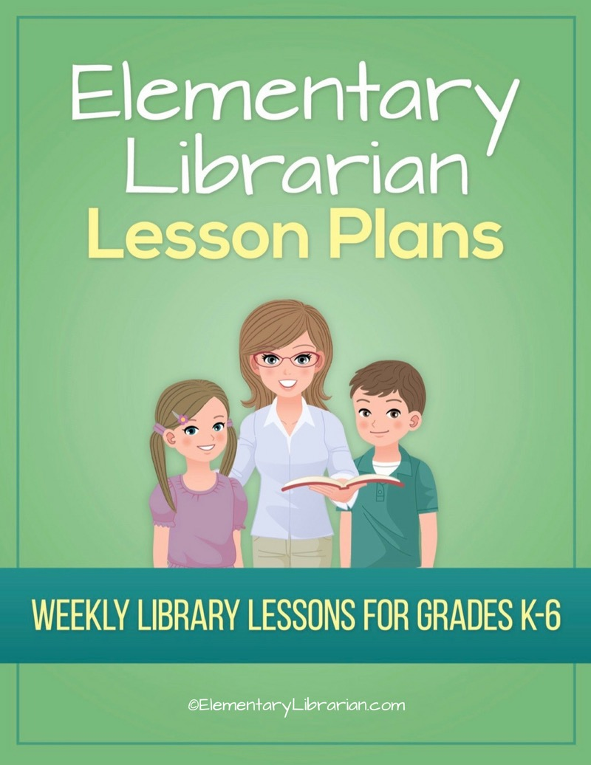

7th Grade Month 1

Watch this video first!
Video link: https://elementarylibrarian.com/how-to
These lesson plans were set up based on seeing classes for 35 minutes each. For more information, check out this article: http://elementarylibrarian.com/about-my-schedule
Here’s a link to the library curriculum map: http://elementarylibrarian.com/library-curriculum
Most of the lesson plans were intended to be used as library stations, or library centers. However, they can also be taught as standalone lessons if you prefer.
To learn more about different options for using these lessons, watch the video above or check out this article: http://elementarylibrarian.com/how-i-use-library-stations
All lesson plan purchases are subject to the Elementary Librarian Terms and Conditions.

Grade Level | 7 | Month | 1 | Week | 1

Objectives | Students will recall using the school library in the past. Students will have an assigned seat and go to that seat when directed. Students will describe desirable library behaviors.
“I Can” Statements | I can describe the rules and procedures for using the library.

Common Core Standards | CC.7.SL.1 Comprehension and Collaboration: Engage effectively in a range of collaborative discussions (one-on-one, in groups, and teacher-led) with diverse partners on grade 7 topics, texts, and issues, building on others' ideas and expressing their own clearly.
 | CC.7.SL.1.c Comprehension and Collaboration: Pose questions that elicit elaboration and respond to others' questions and comments with relevant observations and ideas that bring the discussion back on topic as needed.

AASL Standards | AASL.I.C.4 Inquire: Share: Competency 4: Learners adapt, communicate, and exchange learning products with others in a cycle that includes sharing products with an authentic audience.
AASL.III.D.2 Collaborate: Grow: Competency 2: Learners actively participate with others in learning situations by recognizing learning as a social responsibility.

AASL.III.A.2 Collaborate: Think: Competency 2: Learners identify collaborative opportunities by developing new understanding through engagement in a learning group.

Procedures | 1. Seat students at tables according to seating chart.  2. Introduce library staff to new students.  3. Discuss things students liked about library class last year.  4. Review procedures for entering and exiting the library.  5. Review library rules and general procedures, such as times when students can  access library, rules/procedures for checking out books, how to ask the librarian  for help, etc.

Assessment | Students will demonstrate mastery of entering and exiting the room using the proper procedures. Students will answer basic questions about library rules and procedures.

Additional Resources | Library rules PowerPoint presentation  Library rules Jeopardy game

Grade Level | 7 | Month | 1 | Week | 2

Objective | Students will be able to search the OPAC and use proper checkout procedures.
“I Can” Statement | I can search the OPAC. I can demonstrate proper checkout procedures.

Common Core Standards | CC.7.W.9 Research to Build and Present Knowledge: Draw evidence from literary or informational texts to support analysis, reflection, and research.

AASL Standards | AASL.I.B.1 Inquire: Create: Competency 1 Learners engage with new knowledge by following a process that includes using evidence to investigate questions.  AASL.IV.B.3 Curate: Create: Competency 3: Learners gather information appropriate to the task by systematically questioning and assessing the validity and accuracy of information.  AASL.IV.B.4 Curate: Create: Competency 4: Learners gather information appropriate to the task by organizing information by priority, topic, or other systematic scheme.  AASL.IV.B.1 Curate: Create: Competency 1: Learners gather information appropriate to the task by seeking a variety of sources.  AASL.VI.A.3 Engage: Think: Competency 3: Learners follow ethical and legal guidelines for gathering and using information by evaluating information for accuracy, validity, social, and cultural context, and appropriateness for need.

Procedures | 1. Seat students at tables.  2. Talk about organization in the library.  3. Demonstrate using the OPAC as review (or an introduction for new students).  4. Review checkout procedures.  5. If time allows, students should practice finding books using OPAC.

Assessment | Students will use the OPAC to find books they're searching for.

Additional Resources

Grade Level | 7 | Month | 1 | Week | 3

Objective | Students will be able to describe the tools available to them in the library.
“I Can” Statement | I can describe the different tools I can use to find books and information in the library.

Common Core Standards | CC.7.R.I.10 By the end of the year, read and comprehend literary nonfiction in the grades 6-8 text complexity band proficiently, with scaffolding as needed at the high end of the range.

AASL Standards | AASL.V.A.1 Explore: Think: Competency 1: Learners develop and satisfy personal curiosity by reading widely and deeply in multiple formats and write and create for a variety of purposes.

Procedures | 1. Seat students in their assigned seats at tables.  2. Explain that the library contains many different types of books and many resources designed to help students find books and information.  3. Show library resources PowerPoint presentation.  4. If time, begin scavenger hunt to allow students to explore the library tools and resources.

Assessment | Students will demonstrate their understanding of library resources and procedures by completing a scavenger hunt

Additional Resources | Library resources PowerPoint presentation  Library resources scavenger hunt

Grade Level | 7 | Month | 1 | Week | 4

Objective | Students will be able to describe the tools available to them in the library.
“I Can” Statement | I can describe the different tools I can use to find books and information in the library.

Common Core Standards | CC.7.R.I.10 By the end of the year, read and comprehend literary nonfiction in the grades 6-8 text complexity band proficiently, with scaffolding as needed at the high end of the range.

AASL Standards | AASL.V.A.1 Explore: Think: Competency 1: Learners develop and satisfy personal curiosity by reading widely and deeply in multiple formats and write and create for a variety of purposes.

Procedures | 1. Seat students in their assigned seats at tables.  2. Briefly review tools/resources from previous class.  3. Have students complete tools/resources scavenger hunt.

Assessment | Students will demonstrate their understanding of library resources and procedures by completing a scavenger hunt

Additional Resources | Library resources PowerPoint presentation  Library resources scavenger hunt

